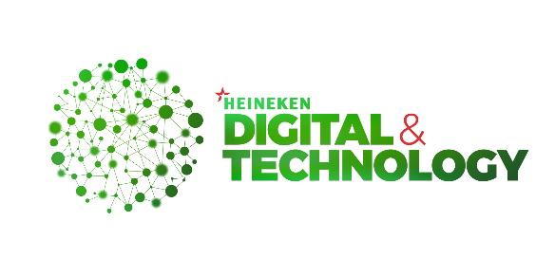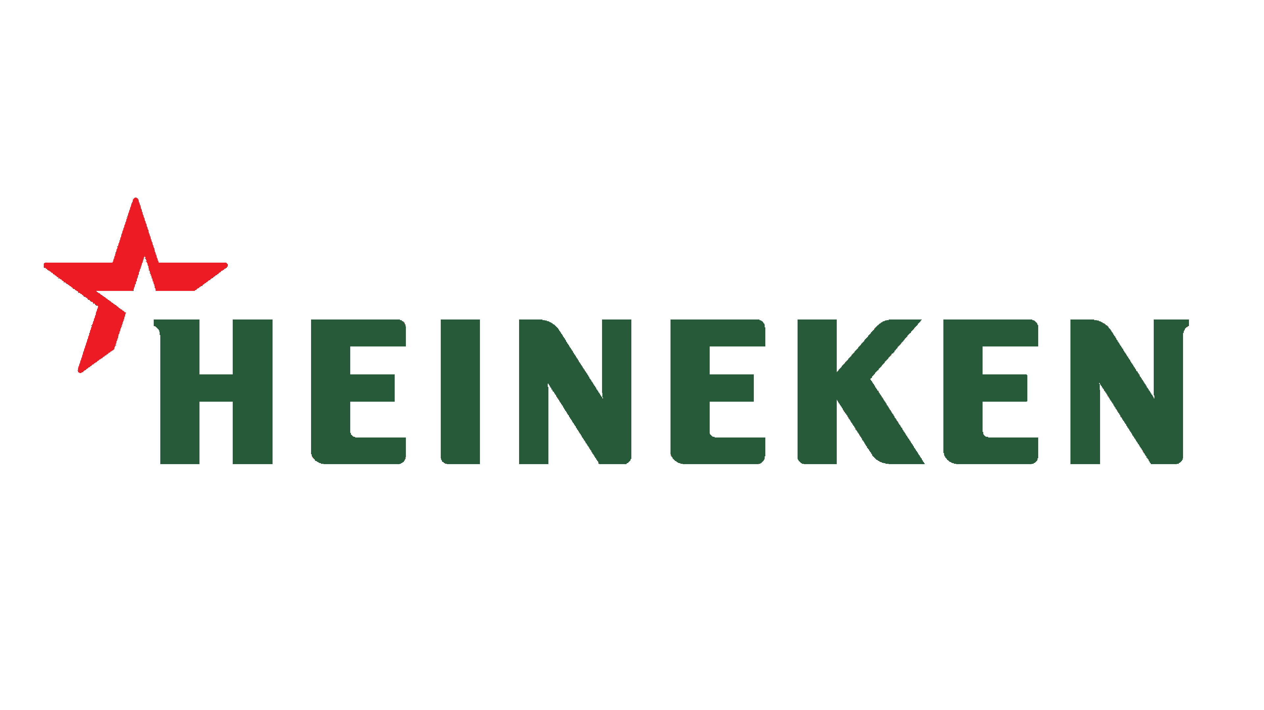

**Stakeholders Meeting**

**HEINEKEN Cambodia**

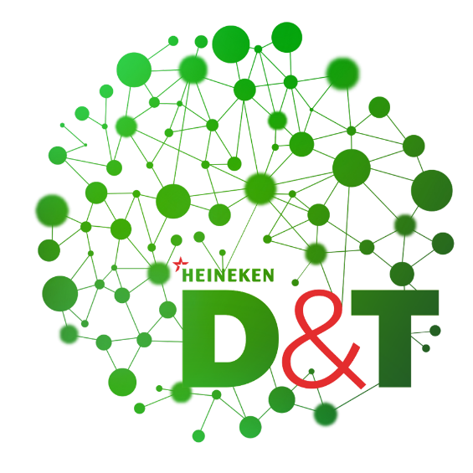

**TPO & Customer Targeting**

**Recommendation**

1. **TMK Responsibilities**
2. What are the main responsibilities of the trade marketing team?
3. Who are responsibilities on trade term program and monitor the effectiveness?
4. **Trade Program Questions List**
5. How many types of trade programs do we apply into the market?
6. Who’s design the trade program theme? TMK, BC?

Meganiche review by the TMK first then go to BC and need alignment from the stakeholders as well.

Designer: TMK Team

1. How did you do when we want to apply a trade to the target?
2. What difficulties of master data do you meet with the program activation?
3. What is the different between VOLUME and PROFIT?

When we do the program. It’s important to do the alignment stakeholders.

Need business case and sign it out.

They follow the activation calendar (commercial alignment).

BTL: Below the line

ATL: Above the line

TTL: Through the line

1. What are the key matric do you look into then you have new program to target the customer?

* Segmentation
* Volume
* Area

1. How can we know it meets the goal or reach KPI?
2. Do you have the platform/system to handle on trade marketing?
3. How many outlets are currently targeted? Why them?
4. **Master Data Questions List**
5. What the data did you use on trade program targeting?
6. What the information do you use to determine the trade term program?

Sopheak Nong

